**SAP Functional Specification**



|  |  |
| --- | --- |
| Project | **SOW-22-N013 SAP - Concur P-Card Integration** |
| Customer | **Serco Group PLC** |
| Solution | **SAP to Concur Integration** |
| Version | **0.2** |
| Author | **Gauree Bhave** |
| Date | **29.06.2022** |

Template Control

| Version | Date | Author | Notes |
| --- | --- | --- | --- |
| 0.1 | 13th August 2013 | Malcolm Smith | Created from existing templates |
| 1.0 | 4th Sept 2013 | John Brinkworth | First Issue |

Document Control

| Version | Date | Author | Notes |
| --- | --- | --- | --- |
| V 0.1 | 29th June 2022 | Gauree Bhave | Initial Draft |
| V 0.2 | 29th June 2022 | Shreya Poojary | Revised after DA’s feedback |

Document Location

| Location |
| --- |
|  |

Approval

| Name | Role | Date | Signature |
| --- | --- | --- | --- |
|  |  |  |  |

Distribution

| Name | Role |
| --- | --- |
|  |  |

Table of Contents

1

1 Overview 5

1.1 Overview & Scope 5

1.2 Assumptions 5

1.3 System Functional Area 5

1.4 Transaction Volumes 5

1.5 Frequency & Timing 5

1.6 Processing Type 5

1.7 Output Device 5

1.8 Security Requirements 5

1.9 Constraints 5

1.10 Dependencies 5

2 Detailed Functional Requirements 6

2.1 Functional Specification 6

2.1.1 Code Enhancement 6

2.2 Process/Data Flow Diagram 8

2.3 Configuration Requirements 8

2.4 Existing Sample Program 8

2.5 Source Systems 9

2.6 Extract File Names & Structure 9

2.6.1 File Names 9

2.6.2 File Names 9

2.7 Extract Data Fields 10

2.8 Input Data Fields & Mapping 11

2.9 Performance Considerations 12

2.10 Error Handling 12

2.11 Reconciliation Procedures & Audit Requirements 12

2.11.1 Approach 12

2.11.2 Metrics 12

2.12 Reporting 12

2.13 Layout 12

3 Testing Requirements 12

3.1 Key Business Test Conditions 12

3.2 Results Verification 12

4 Outstanding Issues 14

5 Annex A – Product Description (reference only) 15

Table of Figures

**No table of figures entries found.**

Table of Tables

Table 1 – Extract Data Fields 9

Table 2 – Data Fields & Mapping 10

Table 3 – Outstanding Issues 13

# Overview

## Overview & Scope

To support the approval process for PCard expenses, SAP outbound interface would be required to send WBS approvers from SAP ECC to Concur System. The scope of this project is to design and build the interfaces between SAP and Concur to manage PCard processes in Concur.

**In scope:**

* Development of New outbound Interface for Concur Statement Employee Import (370) Extract to extract WBS owner’s Employee number.
* UK region is in scope (including VIVO employees)

**Out of scope:**

* No changes to Concur Emp-Login ID Updates (320) & Travel Addendum (350) Extracts.
* Master Data Maintenance

## Assumptions

Employee data for P-Card Statement users and approvers will flow from SAP HCM to Concur with the 320 employee extract.

## System Functional Area

|  |  |  |  |  |
| --- | --- | --- | --- | --- |
| **System** | **Development** | **Quality** | **Preproduction** | **Production** |
| SAP ECC | ED1-210 | EQ2-600 | ER3-600 | EP1-600 |
| SAP PI - Integration | XD1-200  XDJ | XQ1-600  XQJ | Not Applicable | XP1-600  XPJ |

## Transaction Volumes

Only UK region including VIVO employees in scope

## Frequency & Timing

Daily basis - Full load

## Processing Type

Batch Job Processing

## Output Device

NA

## Security Requirements

SAP PI uses key-based authentication to communicate CONCUR SFTP and uses PGP Key for encryption.

## Constraints

NA

## Dependencies

NA

# Detailed Functional Requirements

## Functional Specification

**Statement Employee Extract (370 File)**

As part of the P-Card UK Roll out, all the P-Card master data would be maintained in Concur and relevant employee and approvers data would be sent from SAP ECC. In this interface, Employee numbers of the WBS approvers would be sent to Concur required to have P-Card access as a user and approvers.

**Integration/Data Flow Diagram for Statement Employee Extract**

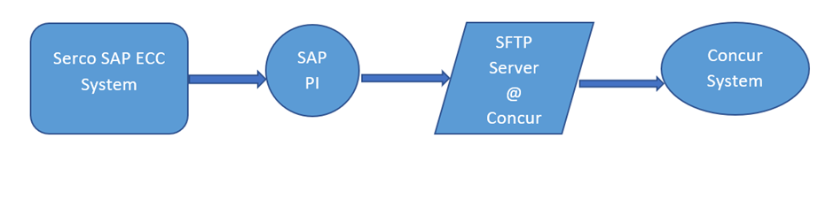

**Program Name:**

ZHR_CONCUR370_PCARD_EXTRACT

**Selection Screen:**

Below is the Selection screen for the new interface:

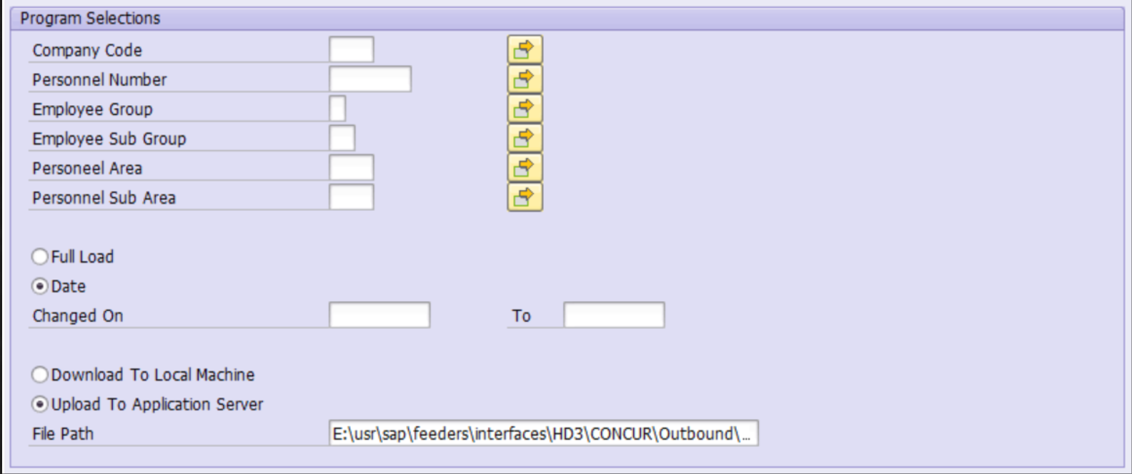

**File Format:**

* File should be in CSV format.
* File naming convention should be “STATEMENTAPPROVER_SAPHCM_CONCUR_STATEMENT_EMPLOYEE_EXTRACT_YYYYMMDDhhmmss.csv”

**Flow Logic:**

* Based on the selection screen the employee data should be picked and updated in the output.
* The report should pull data for the employees as on execution date.
* Below is the logic to extract Employee ID (PERNR) of the WBS owner/person responsible:
* Get the Person Responsible number (Technical field name= VERNR) from the table PRPS against the WBS element.
* Pass this number to table TCJ04 where Username (Technical field name= S_USRNAM) is stored against VERNR (Person responsible number) VERNA (Name of the person responsible / name of WBS owner).
* Once, we get the Username (Technical field name= S_USRNAM).
* Pass the username in table PA0105 for field USRID.
* This USER ID is the respective employee’s SAP System user name and its associated PERNR.
* The PERNR obtained from this table would be updated in column B (Employee ID) field.
* Below are the details to default Statement Report User and Statement Report Approver column in Statement Employee Import (370).

|  |  |  |
| --- | --- | --- |
| **Column Name** | **Column Number** | **Defaulted as** |
| Statement Report User | (C) | **Y** |
| Statement Report Approver | (D) | **Y** |

**Below is file template for Statement Employee Import 370.**



**File Transfer:**

* The file would be uploaded to AL11 directory.
* File Path in DEV, QA & PROD systemswould be as follows:
* Development

E:\usr\sap\feeders\interfaces\HD3\CONCUR\Outbound\Statement Approver\   
E:\usr\sap\feeders\interfaces\HD3\CONCUR\Outbound\ Statement Approver\Archive\

* Quality

E:\usr\sap\feeders\interfaces\HQ3\CONCUR\Outbound\Statement Approver\   
E:\usr\sap\feeders\interfaces\HQ3\ CONCUR\Outbound\ Statement Approver\Archive\

* Pre-Production

E:\usr\sap\feeders\interfaces\HQ3\CONCUR\Outbound\Statement Approver\   
E:\usr\sap\feeders\interfaces\HQ3\ CONCUR\Outbound\ Statement Approver\Archive\

* Production

E:\usr\sap\feeders\interfaces\HP1\CONCUR\Outbound\ Statement Approver\   
E:\usr\sap\feeders\interfaces\HP1\ CONCUR\Outbound\ Statement Approver\Archive\

* PI would pick the file and send it to Concur through PGP encryption.
* Concur would receive the file and decrypt it to upload in their system.
* Once the file is picked up by the PI channel, it would be moved to archive folder.

## Process/Data Flow Diagram



## Configuration Requirements

NA

## Existing Sample Program

NA

## Source Systems

SAP ECC

## Extract File Names & Structure

### File Names

STATEMENTAPPROVER_SAPHCM_CONCUR_STATEMENT_EMPLOYEE_EXTRACT _YYYYMMDDhhmmss.csv

### File Names

NA

## 

## Extract Data Fields

|  |  |  |  |  |  |  |  |  |  |  |
| --- | --- | --- | --- | --- | --- | --- | --- | --- | --- | --- |
| **Field Name** | **Technical Field Name** | **Length** | **Type** | **Mandatory** | **Default Fields** | **Source Field ID** | **Source Name** | **Source Length** | **Mapping Details** | **Comments /Issues** |
| Trx Type |  |  |  |  | 370 |  |  |  |  |  |
| Employee ID | PERNR | 8 Numeric Characters |  | Yes | NA |  | Personnel Number | 8 Numeric Characters |  | Get VERNR maintained against POSKI in PRPS. Pass the VERNR to TCJ04 & get S_USRNAM. Pass this S_USRNAM to PA 0105 table to get PERNR. This PERNR would be displayed in the Employee ID (Column A) of the extracted file. |
| Statement Report User | NA | NA |  | Yes | “Y” |  |  |  |  | To be defaulted in the program |
| Statement Report Approver | NA | NA |  | Yes | “Y” |  |  |  |  | To be defaulted in the program |

Table 1 – Extract Data Fields

## Input Data Fields & Mapping

|  |  |  |  |  |  |  |  |  |  |  |
| --- | --- | --- | --- | --- | --- | --- | --- | --- | --- | --- |
| Field Name | Technical Field Name | Length | Type | Mand | Comments e.g. defaults | Source Field ID | Source Field Name | Source Length | Mapping Details | Comments / Issues |
|  |  |  |  |  |  |  |  |  |  |  |
|  |  |  |  |  |  |  |  |  |  |  |
|  |  |  |  |  |  |  |  |  |  |  |
|  |  |  |  |  |  |  |  |  |  |  |

Table 2 – Data Fields & Mapping

## Performance Considerations

NA

## Error Handling

NA

## Reconciliation Procedures & Audit Requirements

### Approach

NA

### Metrics

NA

## Reporting

NA

## Layout

NA

# Testing Requirements

## Key Business Test Conditions

|  |  |
| --- | --- |
| **S.No** | **Test Case** |
| 1. | Run the 370 extract for UK employees & validate the employee ID in the output. |
| 2. | Terminate the person responsible/WBS owner. Run the Concur 370 Extract. |
| 3. | Maintain past, effective and future dated owner for a WBS element. To validate only active WBS owner as on date of execution is picked up. |

## Results Verification

|  |  |
| --- | --- |
| **S.No** | **Test Result** |
| 1. | PERNR of WBS Responsible Person is reflected as the Employee ID in the file. |
| 2. | The program would return a “No data found” prompt on the output screen. |
| 3. | WBS owner active as on date of execution would be picked up. |

# Outstanding Issues

NA

|  |  |  |  |  |  |  |
| --- | --- | --- | --- | --- | --- | --- |
| Issue No | Description | Assigned To | Status | Impact | Resolution | Expected Date of Resolution |
|  |  |  |  |  |  |  |
|  |  |  |  |  |  |  |
|  |  |  |  |  |  |  |
|  |  |  |  |  |  |  |

Table 3 – Outstanding Issues

# Annex A – Product Description (reference only)

For reference purposes only – Delete if required

|  |  |
| --- | --- |
| **Product Description** | |
| **What?** | The SAP Functional Specification is a detailed description of the purpose of a development, and how/what it should do in specific circumstances. It should describe the essential technical requirements, including the procedures by which it can be determined that the requirements have been met. |
| **Why?** | The benefits of completing a SAP Functional Specification are:   * To provide clear documentation to the programmer of what the development is required to do. * To use as a reference point in discussions with the business, to ensure that what is being designed meets the business requirement. |
| **Who?** | The SAP Functional Consultant is responsible for:   * Documenting the functional requirements.   The SAP Functional Lead is responsible for:   * Reviewing and approving the content of the functional specification.   The Business is responsible for:   * Reviewing and approving the content of the functional specification.   The Project Manager is responsible for:   * Ensuring that a Functional Specification document is completed for each development. |
| **When?** | The Functional Specification should be completed in the Implementation phase.  Dependencies**:**  The Functional Specification should be delivered with the following considerations:   * Design of the Solution Blueprint. |
| **Hints and Tips** | N/A |
| **Next Steps** | Once completed you should consider the following products or actions:   * Technical Specifications * Testing * Change Control |